
American International University-Bangladesh (AIUB)
Department of Computer Science
Faculty of Science & Technology (FST)
CAMPUS ROUTE BUDDY
Project Report
Semester: Summer 25-26
Group: ____02______________ |  | Section: __E________________
SL | Student Name | Student ID
1 | MD. Sabit Rahman Chowdhury | 23-53442-3
2 | Istiauque Hossain Akib | 24-55934-1
3 | Arnob Das | 24-55918-1
4 | Iftekhar Ahmed | 24-56692-1
5 | Md. Istiak Ahmed Siam | 24-56699-1

Assessment Rubric
CO1: Explain the impact of software engineering over various contexts of software development to assess societal, health, safety, legal and cultural issues.
Student ID | Problem Analysis [3] | Socio-cultural Impact [3] | Related Solutions and Studies [4]
1.
2.
3.
4.
5.

CO2: Explain software engineering principles considering professional responsibilities and societal impacts.
Student ID | Conceptual Understanding [3] | Principle Selection and Justification [3] | Application in Software Development Context [4]
1.
2.
3.
4.
5.

Table of Contents
1. Project Proposal | 4
1.1 Background to the Problem | 4
1.2 Selection of Process Model | 4
2. Timeline Chart / Gantt Chart | 5
3. Software Requirements Specification (SRS) / PRD | 5
3.1 Scopes and Features | 5
3.2 User Story Table | 7
3.3 Requirements Traceability Matrix | 9
3.3.1 Functional Requirements | 10
3.3.2 Non-Functional Requirements | 13
- Software Design | 14
4.1 System Design | 14
4.2 UI Design With Figma | 15
- Trello Board | 26
- Git Workflow | 26
- Conclusion | 28

1. PROJECT PROPOSAL

1.1 Background to the Problem
University students often leave campus at similar times and travel toward the same or nearby destinations. However, many students do not know which classmates or verified students are travelling in the same direction. As a result, students may travel alone even when a suitable route companion is available. This creates a practical and safety-related problem, especially after evening classes, during bad weather, or when students are new to the campus area.
Campus Route Buddy is proposed as a student route-matching and safe travel companion system. The system allows a verified student to enter a start location, destination, departure time, and travel mode. Based on this information, the system suggests verified students or available route groups travelling in a similar direction. Students can view limited route-related profiles, send requests, join groups, select approved campus meeting points, coordinate with accepted group members, and share a limited trip summary with a trusted contact for safety support.
The project has important societal and safety value because it encourages students to travel in a more organized and trusted way within the university community. It also supports cultural comfort because some students may prefer travelling with verified university students rather than unknown people. The system avoids showing private home details and focuses on necessary route information only.
The system also considers legal and ethical concerns. It does not calculate transport cost, manage payment, or handle private financial arrangements between students. It does not publicly display exact home addresses or unnecessary personal information. Trusted contacts receive only limited trip-summary information shared by the student. The main purpose is to help verified students find suitable route companions in a safe and organized manner.

1.2 Selection of Process Model
Selected Process Model: Scrum Model
The Scrum Model is selected for Campus Route Buddy because the project is group-based and the work can be divided into short sprint tasks. Scrum is an Agile process model where known requirements are organized in a Product Backlog, prioritized, selected for a Sprint Backlog, completed through sprints, reviewed, and improved. In this project, Trello will be used to track tasks and Figma will be used to design screens for each selected user story.
Scrum Model visualization:
Pre-game Planning | Product Backlog | Sprint Planning & Sprint Backlog | Figma Design | Sprint Review & Feedback | Post-game Finalization
Why this model is suitable:
- The project is group-based and Scrum supports teamwork, role distribution, and regular progress tracking.
- The user stories can be converted into Product Backlog items and Trello cards.
- The work can be divided into sprints such as proposal writing, SRS preparation, Figma wireframes, student screens, admin screens, and final documentation.
- Feedback from the teacher and group members can be reviewed after each sprint and used to improve the design.
- It is more suitable than Waterfall because requirements and UI flow may change during review, while Scrum supports iterative improvement.

2. Timeline Chart / Gantt Chart
The following timeline shows the planned project activities up to the completion of the SRS and non-functional requirements section.
Task | W1 | W2 | W3 | W4 | W5 | W6 | Remarks
Project idea selection and problem analysis | ✔️
Background study and target user identification | ✔️
Requirement collection and user story preparation |  | ✔️
Process model selection and justification |  |  | ✔️
Scope and feature definition |  |  | ✔️
Figma wireframe planning |  |  |  | ✔️
User story board finalization |  |  |  | ✔️
Requirements Traceability Matrix |  |  |  |  | ✔️
Functional requirements writing |  |  |  |  | ✔️
Non-functional requirements writing |  |  |  |  |  | ✔️
Report review and correction |  |  |  |  |  | ✔️

3. SOFTWARE REQUIREMENTS SPECIFICATION (SRS) / PRD
This section defines the scope, features, actors, user stories, traceability, functional requirements, and non-functional requirements of Campus Route Buddy.

3.1 Scopes and Features
Project Scope
Campus Route Buddy is a mobile-first route-matching and safe travel companion system for university students. The current Figma prototype covers student onboarding, login, profile creation, identity verification, route request creation, suggested buddies, route groups, meeting point selection, trip details, group chat, safety actions, trusted contact sharing, reviews, reports, travel history, and the admin control panel.
Actors and Roles
- Student: The primary user who creates and manages a profile, completes university verification, creates route requests, views suggested buddies, sends/receives requests, joins or creates route groups, selects meeting points, uses chat, shares trip summaries, calls 999, submits reviews/reports, and views travel history.
- Admin: The administrative user who logs into the control panel, views dashboard statistics, approves/rejects verifications, reviews safety reports, suspends unsafe accounts, searches student profiles, views trip records, manages meeting points, manages permissions, edits admin profile, changes password, and views system logs.
- Trusted Contact: An external safety-support actor who does not need to create an app account. A trusted contact can open a read-only shared trip view and see limited trip details shared by a student, such as trip reference, destination area, meeting point, group information and trip status.
In Scope
- Welcome screen, student login, profile creation, profile management, logout, forgot password, OTP verification, and password reset.
- University identity verification using student ID evidence or university email, with Pending/Verified status.
- Travel request creation using start location, destination, departure time, and travel mode.
- Suggested route buddy list showing verified students, route information, rating, and match percentage.
- Route buddy profile view with limited verified information, safety indicators, rating, route and common route details.
- Route buddy request sending, request-sent confirmation, and accept/reject management for received requests.
- Nearby route group viewing, route group creation, route group joining, group status, and member information.
- Approved campus meeting point selection and confirmation.
- Trip detail viewing, trip status tracking, group chat, mark-as-completed flow, review and report submission.
- Route-related group chat for accepted route group members.
- Safety screen with emergency help, call 999, call trusted contact, share trip summary, and report incident options.
- Travel history with status badges such as Completed and Cancelled.
- Admin control panel for dashboard, verifications, safety reports, student profiles, trip records, meeting points, admin profile, permissions and system logs.
Out of Scope
- The system will not calculate transportation cost or divide fares between students.
- The system will not manage payment or financial transactions.
- The system will not display exact home addresses publicly.
- The system will not provide a full real-time navigation system like ride-sharing platforms.
- The current course version focuses on design, SRS, and Figma prototype, not complete coded implementation.
- Trusted contacts will not be allowed to log in, modify trip status, join group chat, or view private student profile details. They can only view the shared read-only trip summary.
Major Features
Feature ID | Feature Name | Description
F-01 | Onboarding and Access | Welcome screen, get started flow, student login, admin login option, and account access.
F-02 | Student Account Management | Create profile, view profile, edit profile, change password, reset password, and logout.
F-03 | Student Verification | Students submit university email or student ID evidence and view Pending or Verified status.
F-04 | Student Dashboard | Student home screen shows active trip status, quick actions, and verification status.
F-05 | Travel Request Management | Create route request with start location, destination, departure time, and travel mode.
F-06 | Route Buddy Matching | Show suggested verified students with route details, rating, distance/time, and match percentage.
F-07 | Route Request Handling | Students can send route buddy requests and accept/reject received requests.
F-08 | Route Group Management | Students can browse nearby groups, create a new group, view group details, and join groups.
F-09 | Meeting Point Selection | Students select approved campus meeting points before confirming a trip or group.
F-10 | Trip Coordination | Trip detail view, trip status, group chat, and mark trip as completed.
F-11 | Safety and Emergency Support | Emergency help, call 999, call trusted contact, share trip summary, and report incident.
F-12 | Review, Report and History | Students can review route buddies, submit reports, and view completed/cancelled travel history.
F-13 | Trusted Contact Support | External trusted contact can view a read-only shared trip summary through a secure shared view.
F-14 | Admin Control Panel | Admin dashboard, verification approval/rejection, safety reports, student profiles, trip records, meeting points, permissions, logs, and admin profile management.

3.2 User Story Table
The following user story table is included from the Campus Route Buddy user story board and updated to include the Trusted Contact actor.
As A/An | I want to | So that | Acceptance Criteria
Student | Get started from the welcome screen | I can enter the Campus Route Buddy app | The Get Started button opens the login or account access flow.
Student | Login with university email and password | The system can authenticate me and open my account | After valid login, the student home dashboard is displayed.
Student | Create a new student profile | I can register myself in the system | The student enters name, department, semester, email and password, then continues to identity verification.
Student | Verify my university identity | Only genuine university students can use route matching | The student submits student ID evidence or university email and the status is shown as Pending or Verified.
Student | View submitted verification status | I know whether my account is still waiting for approval | The submitted-for-review screen shows Verification: Pending and explains that matching is locked until verified.
Student | View my home dashboard | I can quickly access the main route features | The dashboard shows active trip status, quick actions, and identity verification status.
Student | Create a route request | I can search for students travelling in the same direction | The student enters start location, destination, departure time and travel mode, then selects Find Route Buddies.
Student | View suggested route buddies | I can choose a suitable student to travel with | The system displays verified students with route direction, rating and match percentage.
Student | View a route buddy profile | I can check limited safety information before sending a request | The screen shows name initials/photo, department, semester, verification status, rating, route and common route information.
Student | Send a route-buddy request | I can ask another student to travel with me | The selected student receives the request and the sender sees a request-sent confirmation.
Student | Accept or reject received route requests | I can control who travels with me | The route requests screen provides Accept and Reject buttons and updates the request state.
Student | View nearby route groups | I can join an existing group going in a similar direction | The nearby groups screen lists available groups with route, time, member count and status.
Student | Create a new route group | Other students travelling in my direction can join me | The creator enters route details, meeting point, time, group size and tags, then the group is created.
Student | Join an available route group | I can travel with a suitable group | The group detail screen shows meeting point and group information and provides a Join Request button.
Student | Select a meeting point | Group members can meet at an approved and recognizable place | The system displays approved campus meeting points and saves the selected point after confirmation.
Student | View trip details | I can understand the current travel plan | The trip details screen shows route, group, meeting point, members, trip reference and current status.
Student | Use group chat | I can coordinate meeting information with group members | The group chat screen allows accepted members to exchange route-related messages.
Student | Mark trip as completed | The trip can be closed after travel | The trip status changes to Completed and the review screen becomes available.
Student | Review a route buddy | Other students can make safer matching decisions | The review form accepts feedback only after a completed trip and saves the review.
Student | Report another user | Unsafe or inappropriate behavior can be investigated | The report form requires a reason and details, then forwards the report for admin review.
Student | Open the safety screen | I can quickly access safety features when needed | The safety screen shows Emergency Help and options such as share trip, call trusted contact, and report incident.
Student | Call National Emergency 999 | I can seek emergency help when I feel unsafe | The emergency screen explains that calling 999 can share current trip details and provides a Call 999 Now action.
Student | Share trip summary with a trusted contact | Someone I trust can know my trip information | The student selects a trusted contact and shares a summary containing trip reference, destination, meeting point, group and status.
Student | View travel history | I can review previous and upcoming trips | The history screen lists trips by route, date and status such as Completed or Cancelled.
Student | View and edit my profile | I can manage my saved personal and travel information | The profile screen shows identity and verification status, and the edit screen allows valid profile changes.
Student | Reset a forgotten password | I can regain access to my account | The student requests an OTP, enters OTP and new password, and receives a password reset confirmation.
Trusted Contact | View a read-only shared trip summary | I can check the student’s shared route information without creating an account | The shared view shows sender name, trip reference, destination area, meeting point, group information and trip status.
Trusted Contact | Use shared emergency information | I can help the student if something seems wrong | The shared page shows the trip information and does not provide login access, private profile access or group chat access.
Admin | Login with admin credentials | The system can protect the control panel | Valid admin credentials open the admin dashboard.
Admin | View the admin dashboard | I can understand the current system condition | The dashboard shows counts of students, pending verifications, active routes, open reports and recent activity.
Admin | View pending verifications | I can check students waiting for approval | The verification page lists applicants with ID evidence, email/source and submission age.
Admin | Approve or reject verification requests | Only valid students receive verified access | The admin can approve or reject a request and the student verification status is updated.
Admin | View safety reports | I can investigate reported incidents | The safety reports screen lists report references, reporter, reported student, reason and status.
Admin | Review reports and suspend unsafe accounts | Unsafe users can be restricted when necessary | The admin can review report details and suspend a reported account when required.
Admin | Search and view student profiles | I can inspect accounts during verification or investigation | The student profiles screen allows search by name, ID or email and displays rating, trip count and verification status.
Admin | View trip records | I can inspect route records for monitoring or investigation | The trip records screen shows route, members, meeting point, trip reference and status.
Admin | Manage meeting points | Students can choose safe approved locations | The admin can add or manage active/inactive campus meeting points.
Admin | View and edit admin profile | Admin information can be maintained properly | The admin profile and edit profile screens show and update admin name, email, phone and department.
Admin | Change admin password | The control panel account remains secure | The admin enters current password, new password and confirmation before updating the password.
Admin | Manage permissions | Administrative access can be controlled | The permissions screen allows enabling or disabling user-management and report-access permissions.
Admin | View system logs | Admin actions can be audited | The system logs screen lists recent activities such as user approved, report resolved and user rejected.

3.3 Requirements Traceability Matrix
The Requirements Traceability Matrix maps major requirements to their related user stories and expected UI/design components. This helps ensure that every important user story is represented in the SRS and Figma prototype.
Req. ID | Requirement | Related User Story | Design Component | Priority
FR-01 | Welcome and access flow | Get started from the welcome screen | Welcome screen; Get Started button | High
FR-02 | Student login and authentication | Login with university email and password | Student login screen; Home dashboard | High
FR-03 | Student account creation | Create a new student profile | Create Profile screen | High
FR-04 | University identity verification | Verify my university identity; View submitted verification status | Verify Identity screen; Submitted for Review screen; Admin Pending Verifications | High
FR-05 | Student dashboard access | View my home dashboard | Student home dashboard | High
FR-06 | Route request creation | Create a route request | Create Request screen | High
FR-07 | Suggested route buddy viewing | View suggested route buddies | Suggested Buddies screen | High
FR-08 | Route buddy profile viewing | View a route buddy profile | Buddy Profile screen | High
FR-09 | Route buddy request sending | Send a route-buddy request | Send Request screen; Request Sent screen | High
FR-10 | Route request response management | Accept or reject received route requests | Route Requests screen | High
FR-11 | Nearby route group viewing and joining | View nearby route groups; Join an available route group | Nearby Groups screen; Group Details screen | High
FR-12 | Route group creation | Create a new route group | Create New Group screen; Group Created screen | High
FR-13 | Approved meeting point selection | Select a meeting point | Select Meeting Point screen | High
FR-14 | Trip details and status management | View trip details; Mark trip as completed | Trip Details screen; Trip Completed screen | High
FR-15 | Group chat | Use group chat | Group Chat screen | Medium
FR-16 | Trip review | Review a route buddy | Review screen; Feedback confirmation screen | Medium
FR-17 | Incident reporting | Report another user | Report User screen; Report Submitted screen | High
FR-18 | Safety options and emergency help | Open the safety screen; Call National Emergency 999 | Safety screen; Call 999 screen | High
FR-19 | Trip sharing with trusted contact | Share trip summary with a trusted contact | Share Trip screen; Trusted Contact shared view | High
FR-20 | Travel history | View travel history | Travel History screen | Medium
FR-21 | Student profile management | View and edit my profile; Reset a forgotten password | Profile screen; Edit Profile; Forgot Password; Reset Password | Medium
FR-22 | Trusted contact read-only access | View a read-only shared trip summary; Use shared emergency information | Trusted Contact shared trip view | High
FR-23 | Admin login and dashboard | Login with admin credentials; View dashboard | Admin Login; Admin Dashboard | High
FR-24 | Admin verification management | View pending verifications; Approve or reject verification requests | Pending Verifications screen | High
FR-25 | Admin safety report management | View safety reports; Review reports and suspend unsafe accounts | Safety Reports screen; Suspend Account action | High
FR-26 | Admin student profile search | Search and view student profiles | Student Profiles screen | Medium
FR-27 | Admin trip and meeting-point management | View trip records; Manage meeting points | Trip Records screen; Meeting Points screen | Medium
FR-28 | Admin profile and password management | View/edit admin profile; Change admin password | Admin Profile; Edit Profile; Change Password | Medium
FR-29 | Admin permissions and system logs | Manage permissions; View system logs | Manage Permissions screen; System Logs screen | Medium

3.3.1 Functional Requirements
Functional requirements describe what the Campus Route Buddy system must do based on the current Figma prototype and user flows.
Requirement ID | Functional Requirement | Module | Priority
FR-01 | The system shall provide a welcome screen and allow users to start the application flow. | Onboarding and Access | High
FR-02 | The system shall allow students to login using university email and password. | Student Account Management | High
FR-03 | The system shall allow a student to create a profile by entering name, department, semester, email and password. | Student Account Management | High
FR-04 | The system shall allow a student to verify university identity using student ID evidence or university email. | Student Verification | High
FR-05 | The system shall show a student home dashboard with active trip, quick actions and verification status. | Student Dashboard | High
FR-06 | The system shall allow verified students to create route requests with start location, destination, departure time and travel mode. | Travel Request Management | High
FR-07 | The system shall show suggested route buddies with limited route and safety information. | Route Buddy Matching | High
FR-08 | The system shall allow a student to view a route buddy profile before sending a request. | Route Buddy Matching | High
FR-09 | The system shall allow students to send route-buddy requests. | Route Request Handling | High
FR-10 | The system shall allow students to accept or reject received route requests. | Route Request Handling | High
FR-11 | The system shall allow students to view nearby route groups and request to join available groups. | Route Group Management | High
FR-12 | The system shall allow students to create a new route group by providing route, time, meeting point, group size and tags. | Route Group Management | High
FR-13 | The system shall display approved meeting points and allow students to confirm one meeting point. | Meeting Point Management | High
FR-14 | The system shall allow students to view trip details and mark the trip as completed. | Trip Coordination | High
FR-15 | The system shall provide group chat for accepted route group members. | Trip Coordination | Medium
FR-16 | The system shall allow students to submit a review after a completed trip. | Review and Feedback | Medium
FR-17 | The system shall allow students to report unsafe or inappropriate behavior. | Safety and Reporting | High
FR-18 | The system shall provide a safety screen with emergency help and quick safety options. | Safety and Emergency Support | High
FR-19 | The system shall provide a Call 999 emergency action. | Safety and Emergency Support | High
FR-20 | The system shall allow a student to share a trip summary with a trusted contact. | Trusted Contact Support | High
FR-21 | The system shall allow a trusted contact to view the shared trip summary in read-only mode. | Trusted Contact Support | High
FR-22 | The system shall allow students to view travel history. | Travel History | Medium
FR-23 | The system shall allow students to manage profile information and password recovery. | Student Account Management | Medium
FR-24 | The system shall allow admin login and admin dashboard access. | Admin Control Panel | High
FR-25 | The system shall allow admin to approve or reject pending student verifications. | Admin Verification Management | High
FR-26 | The system shall allow admin to view safety reports and suspend unsafe accounts when necessary. | Admin Safety Report Management | High
FR-27 | The system shall allow admin to search student profiles and view trip records. | Admin Monitoring | Medium
FR-28 | The system shall allow admin to manage approved meeting points. | Admin Meeting Point Management | Medium
FR-29 | The system shall allow admin to manage admin profile, password, permissions and system logs. | Admin Account and Audit Management | Medium

3.3.2 Non-Functional Requirements
Non-functional requirements describe how well the system should operate. For Campus Route Buddy, the most important quality concerns are safety, privacy, security, access control, usability, data integrity and auditability because the system deals with student identity, route information, emergency support and admin decisions.
Requirement ID | Non-Functional Requirement | Quality Attribute | Related Module | Priority
NFR-01 | The interface shall be simple enough for students to create a route request and access safety options with minimum steps. | Usability | Student UI / Figma Prototype | High
NFR-02 | Only verified students shall be allowed to use route matching and group joining features. | Security | Student Verification | High
NFR-03 | Admin functions shall be accessible only through a separate admin login and admin control panel. | Access Control | Admin Control Panel | High
NFR-04 | The system shall not publicly display exact home address, private phone number, private email, full student ID or unnecessary personal information. | Privacy | Student Profile and Route Matching | High
NFR-05 | Trusted contact access shall be read-only and limited to the shared trip summary. | Privacy / Access Control | Trusted Contact Support | High
NFR-06 | The system shall support student safety through verified users, approved meeting points, emergency help, trip sharing, reporting and admin review. | Safety | Safety and Reporting | High
NFR-07 | Emergency actions shall be highly visible and easy to understand. | Emergency Usability | Safety and Emergency Support | High
NFR-08 | Route buddy suggestions and route group information should be displayed quickly after request submission under normal use. | Performance | Route Buddy Matching | High
NFR-09 | The system shall correctly update important statuses such as Pending, Verified, Accepted, Rejected, In Progress, Completed, Cancelled, Suspended and Resolved. | Reliability | Status Management | High
NFR-10 | The system should be available during common student travel times so students can create/check requests and use safety options. | Availability | Route Request and Safety Modules | High
NFR-11 | The design and documentation shall be organized so new screens or requirement changes can be added easily. | Maintainability | Overall Documentation and Figma Design | Medium
NFR-12 | The system should be scalable enough to support more students, route requests, route groups, reports and admin records in the future. | Scalability | Overall System | Medium
NFR-13 | The UI shall be designed mainly for mobile screens and should be adaptable for future web or tablet views. | Compatibility | UI / Figma Design | Medium
NFR-14 | The prototype shall use readable text, clear icons, proper contrast and visible action buttons. | Accessibility | UI / Figma Design | Medium
NFR-15 | The system shall preserve data integrity for profile information, verification status, route requests, reports, reviews, trip records and admin decisions. | Data Integrity | Student, Trip, Report and Admin Records | High
NFR-16 | The system shall keep important admin action records such as user approved, report resolved, user rejected and permission changes. | Auditability | System Logs and Admin Management | High
NFR-17 | The system shall not calculate transport cost, manage payment or handle private financial arrangements between students. | Ethical and Scope Constraint | Project Scope Control | High
4. SOFTWARE DESIGN
This section describes the system design and user interface design of Campus Route Buddy. The system design explains the actors, their roles, and their interaction with the system through a use case diagram. The UI design section presents the Figma prototype screens developed from the SRS, user stories, and functional requirements.
4 Software Design:
4.1 System Design:

4.2 UI Design using Figma
Siam:
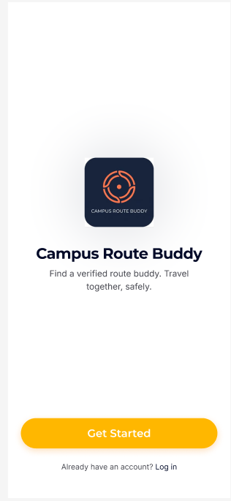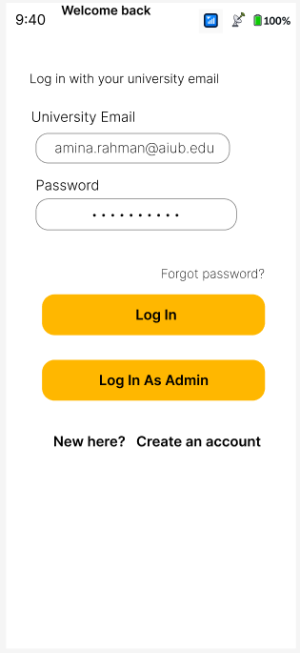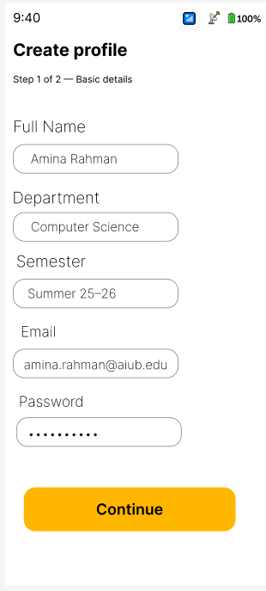
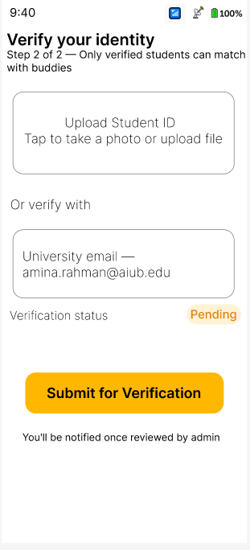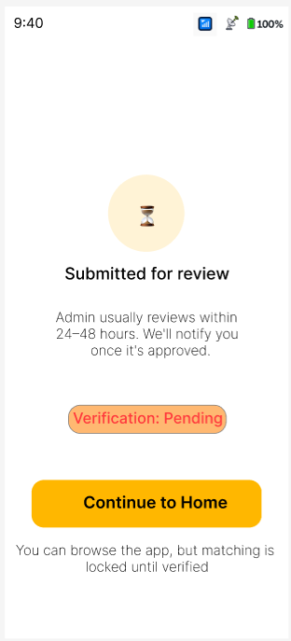
Iftekhar:
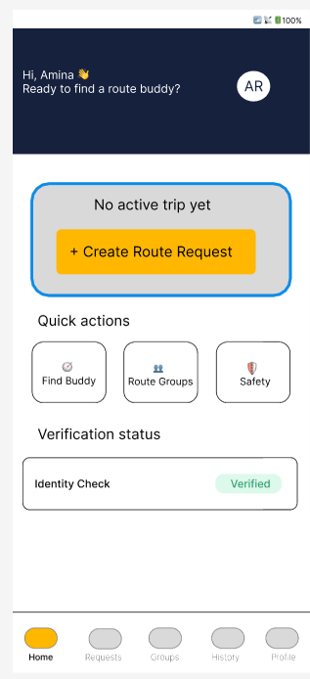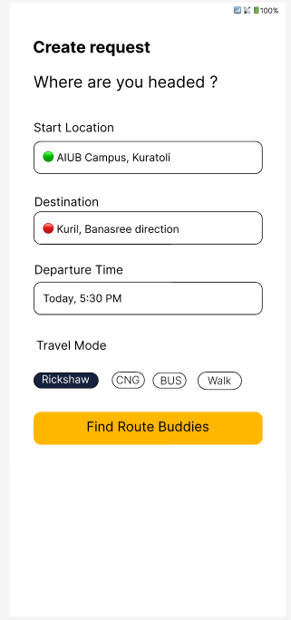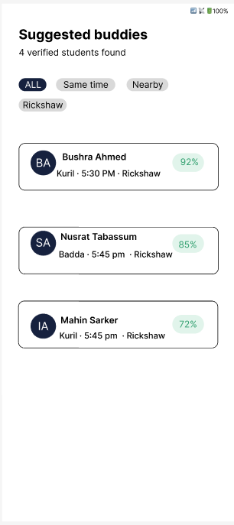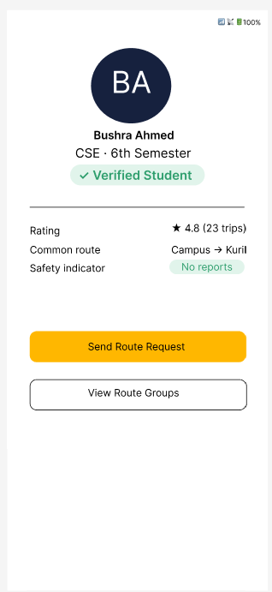
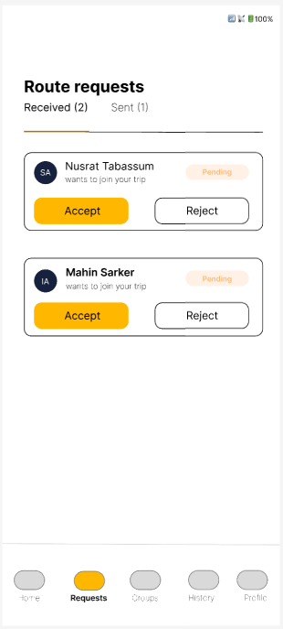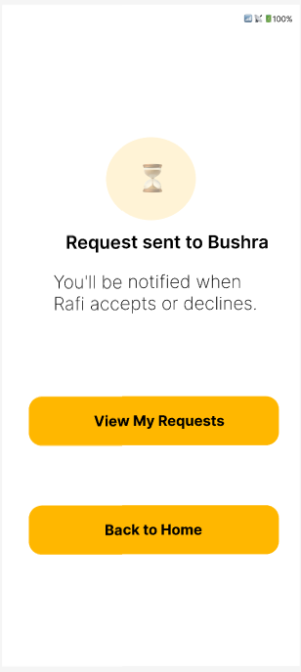
Istiauque :
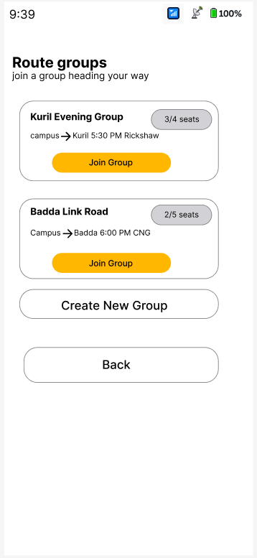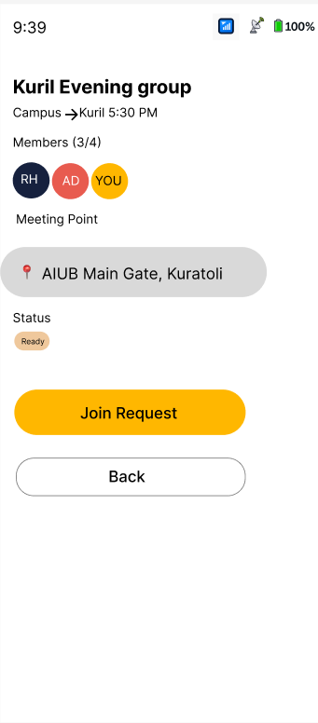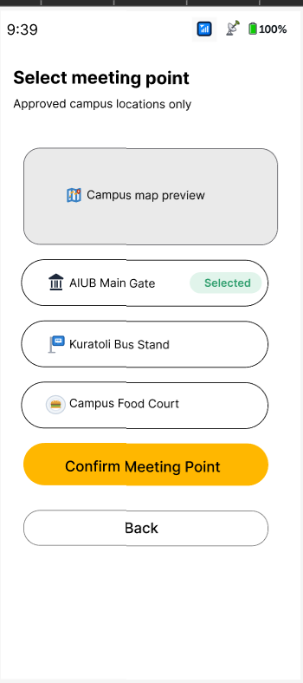
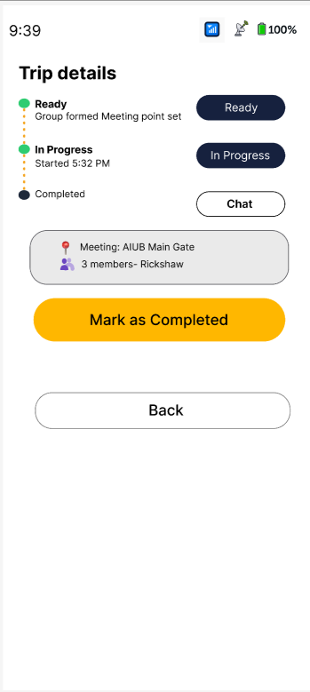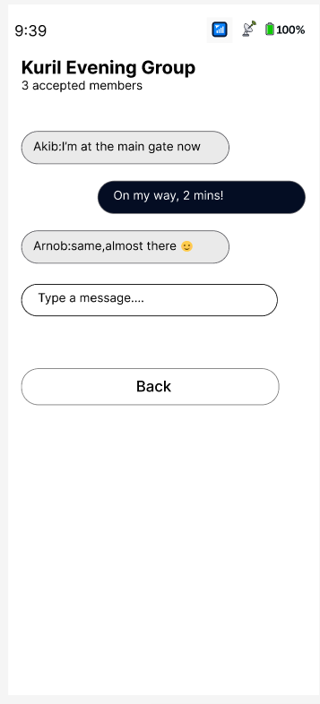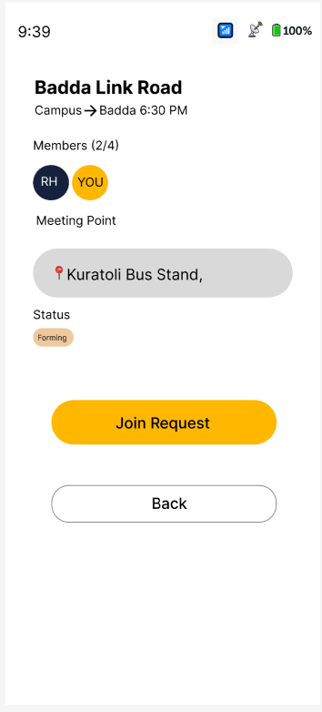
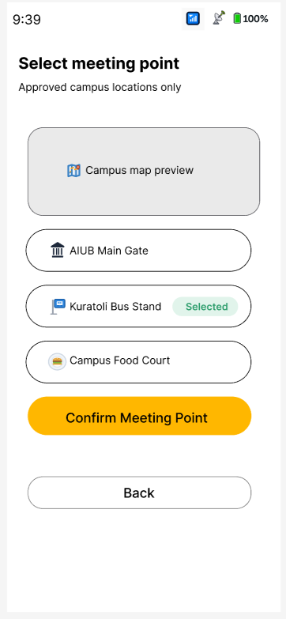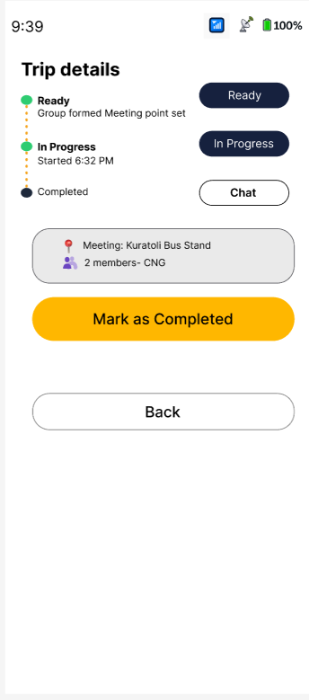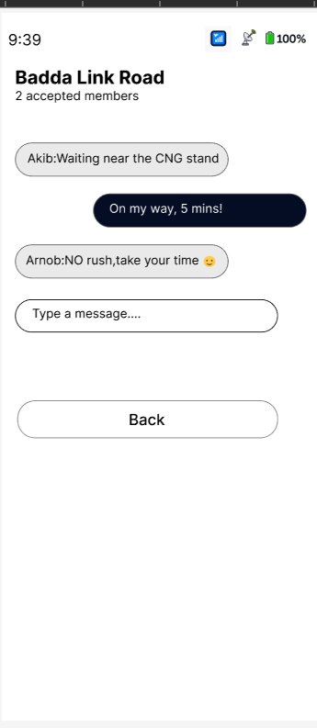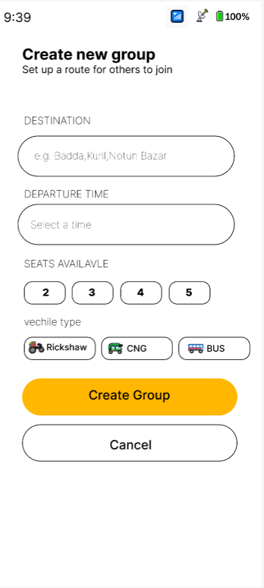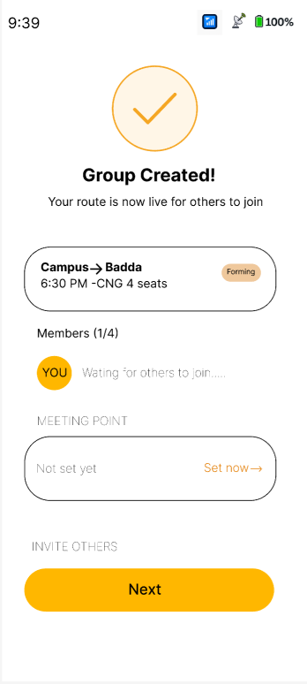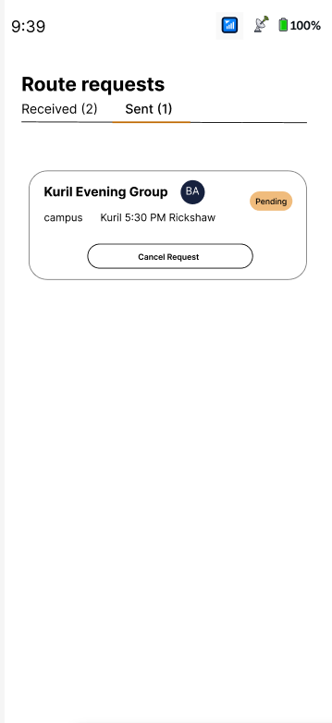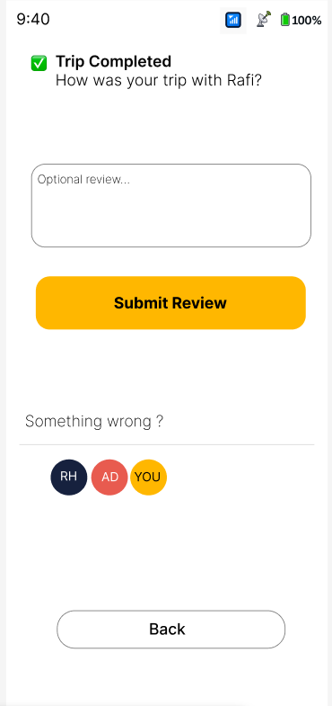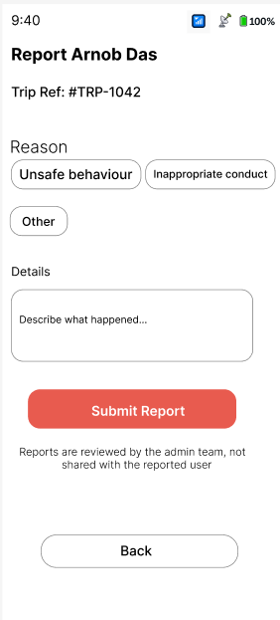
Arnob :
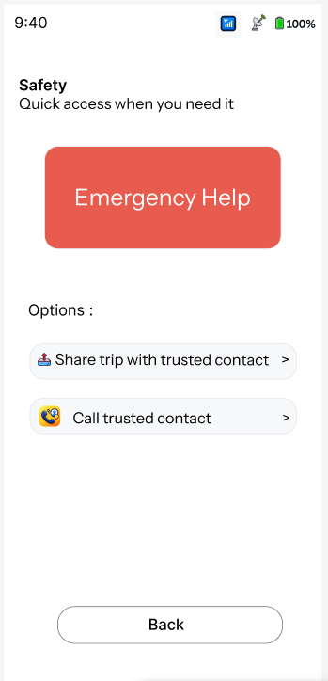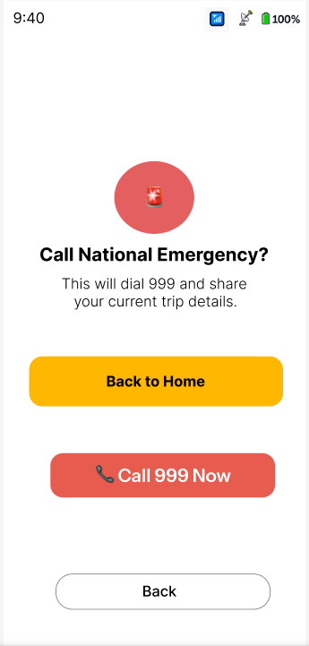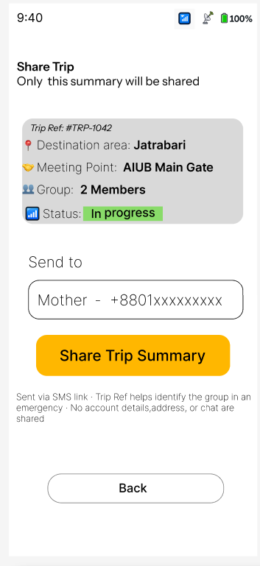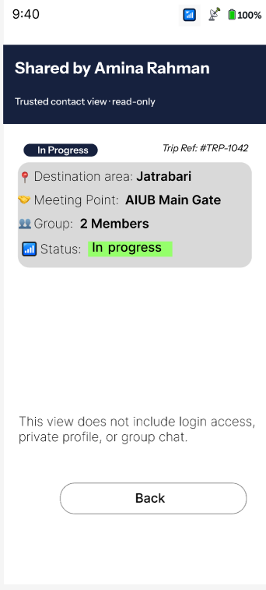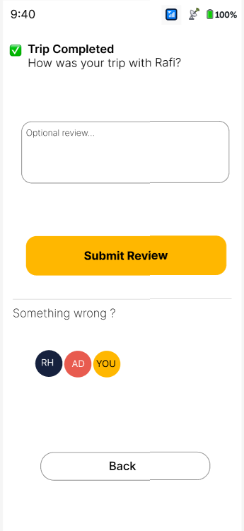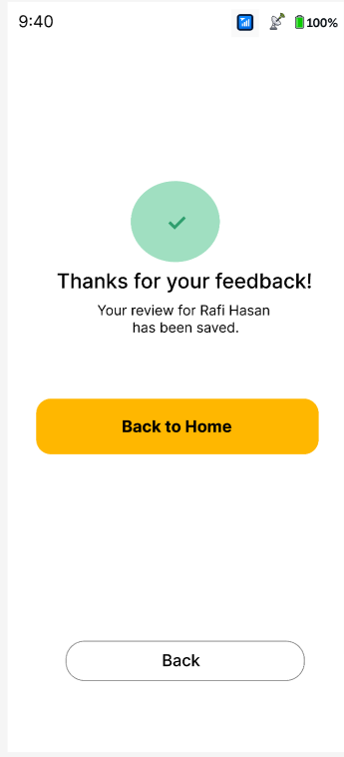
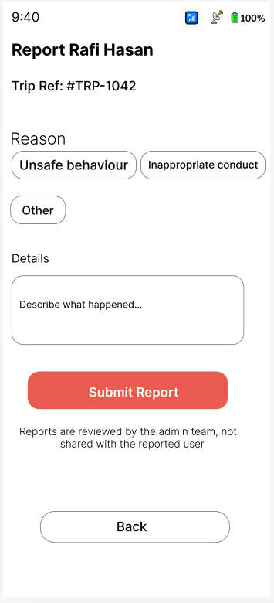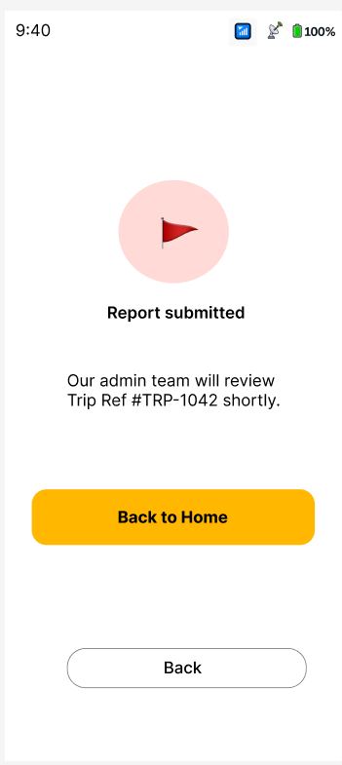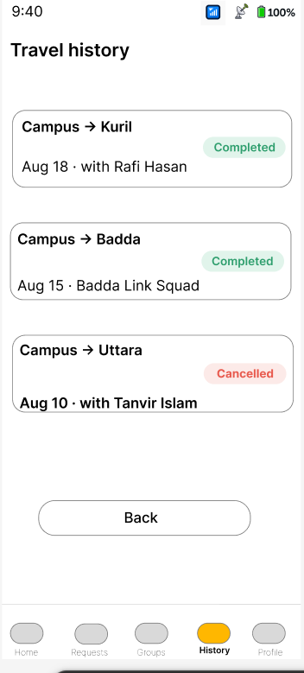
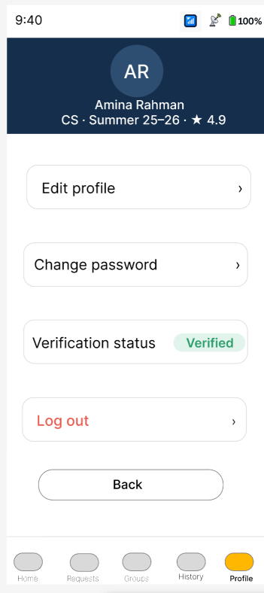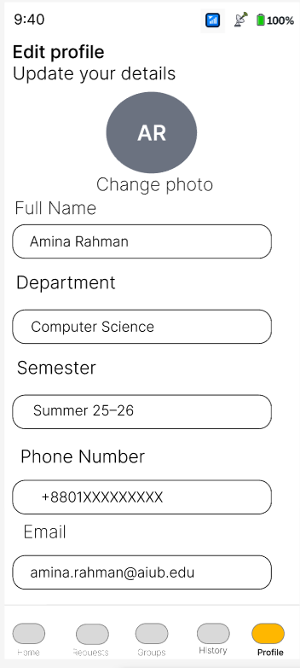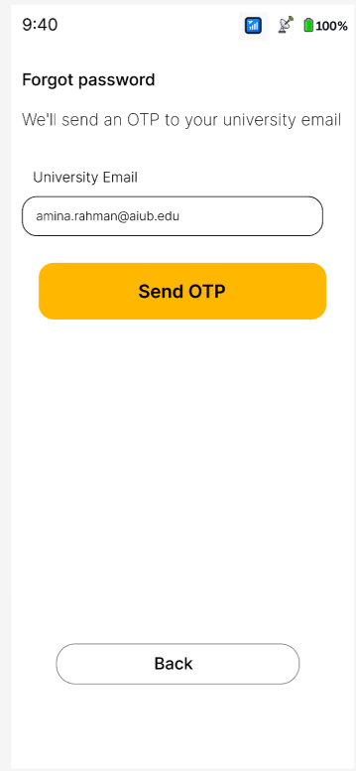
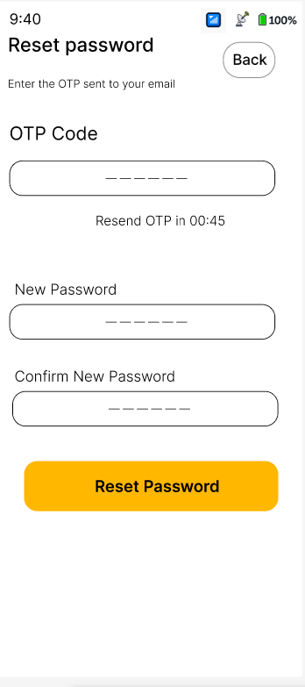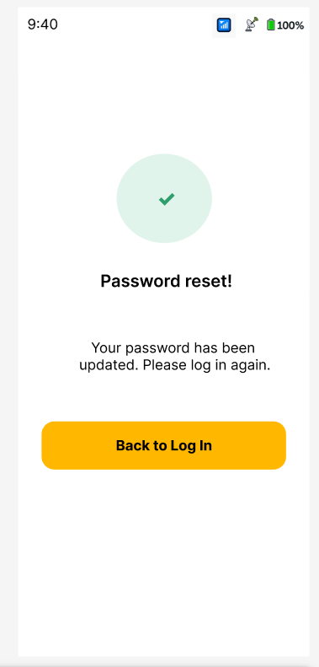

Sabit:
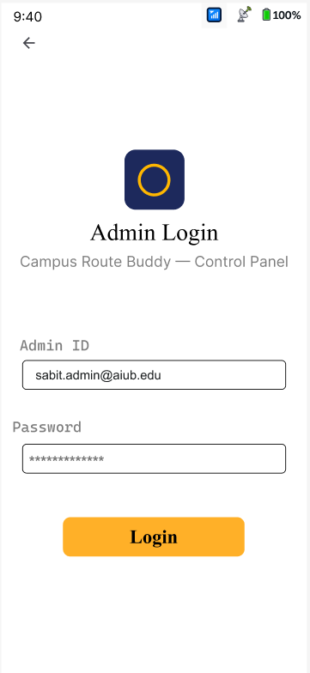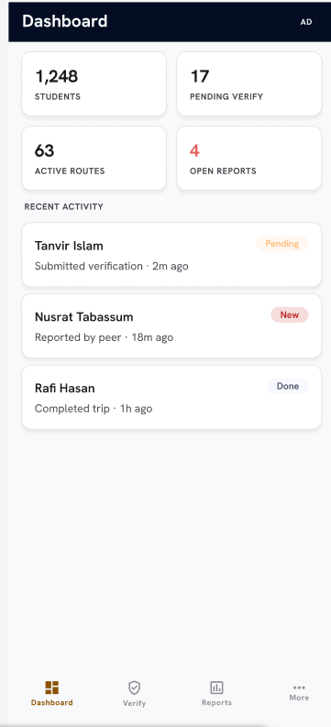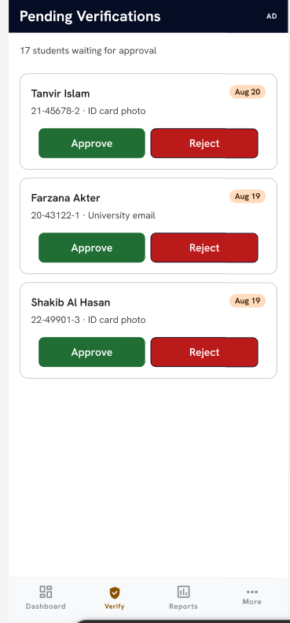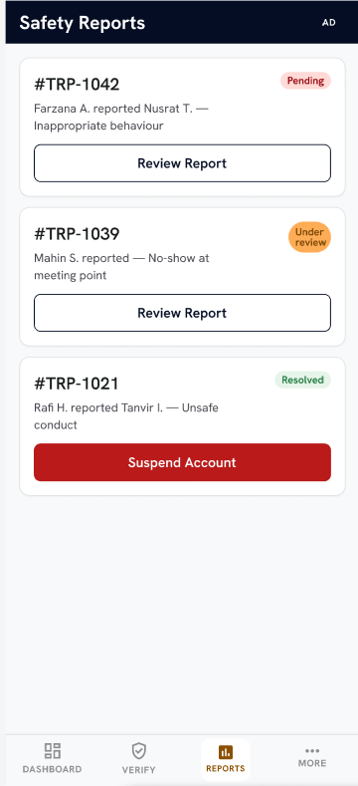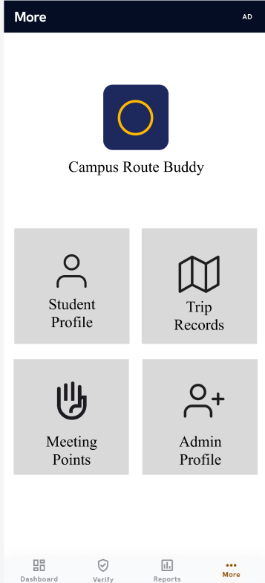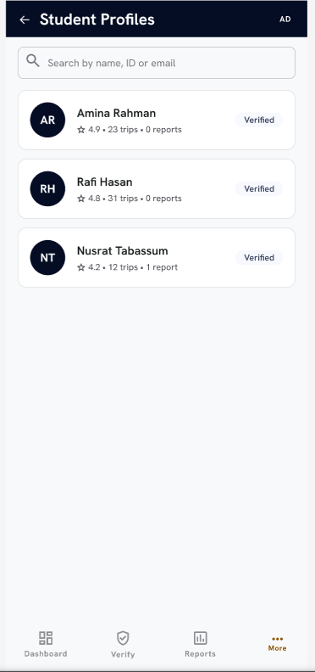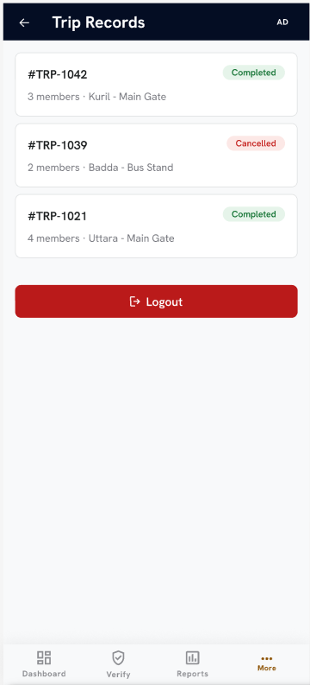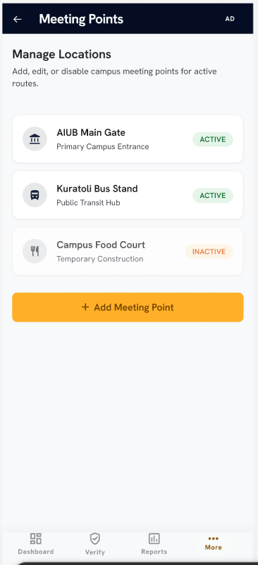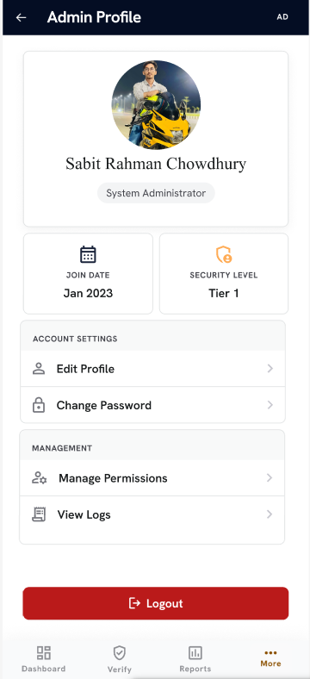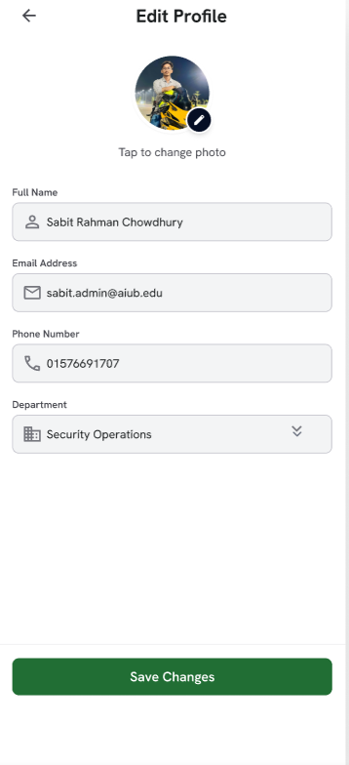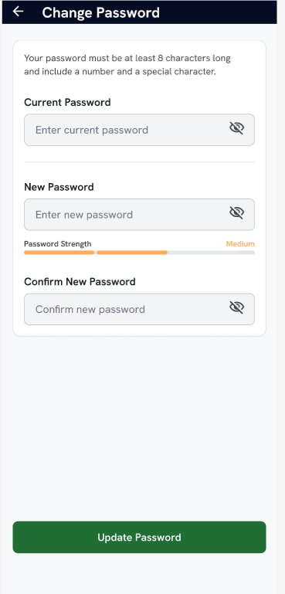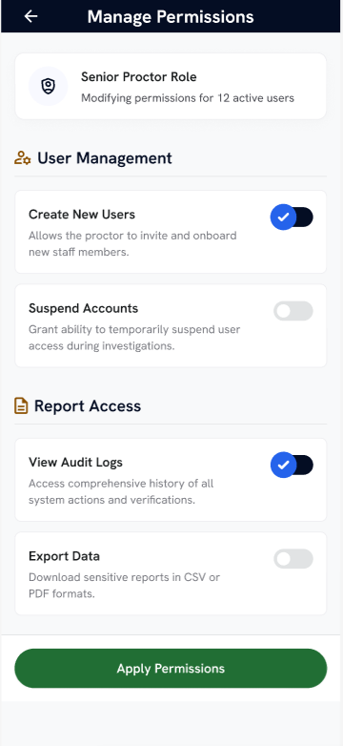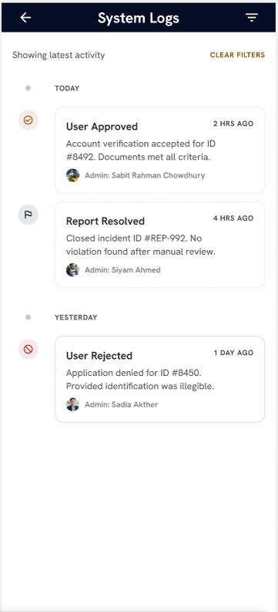
5.Trello Board
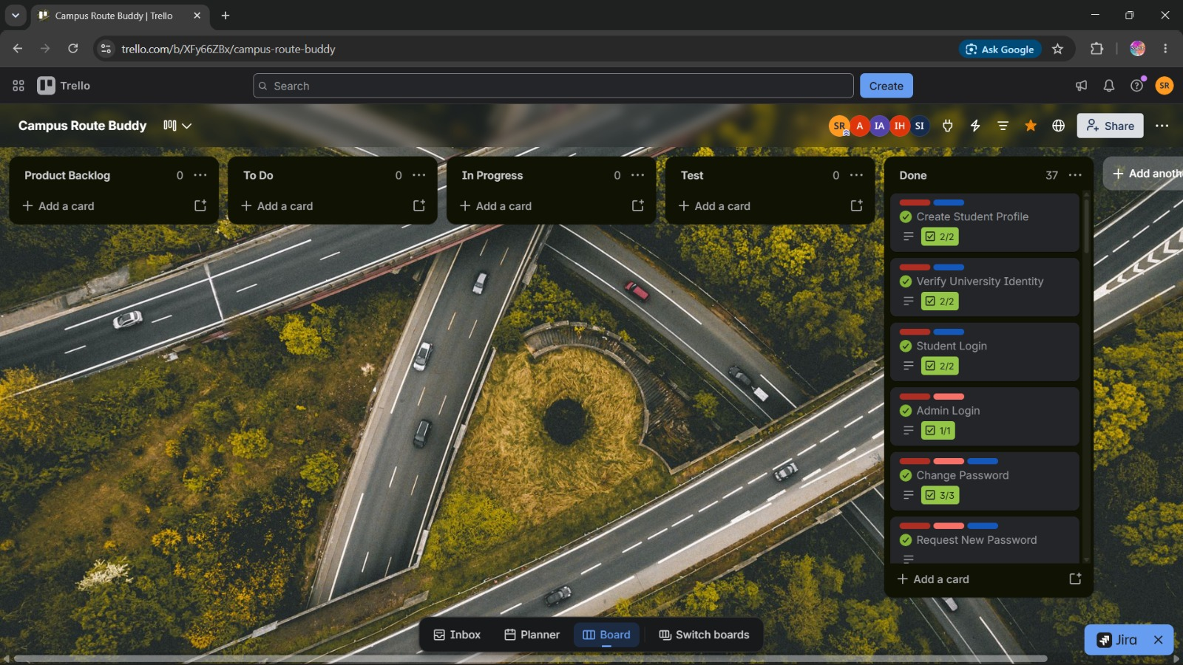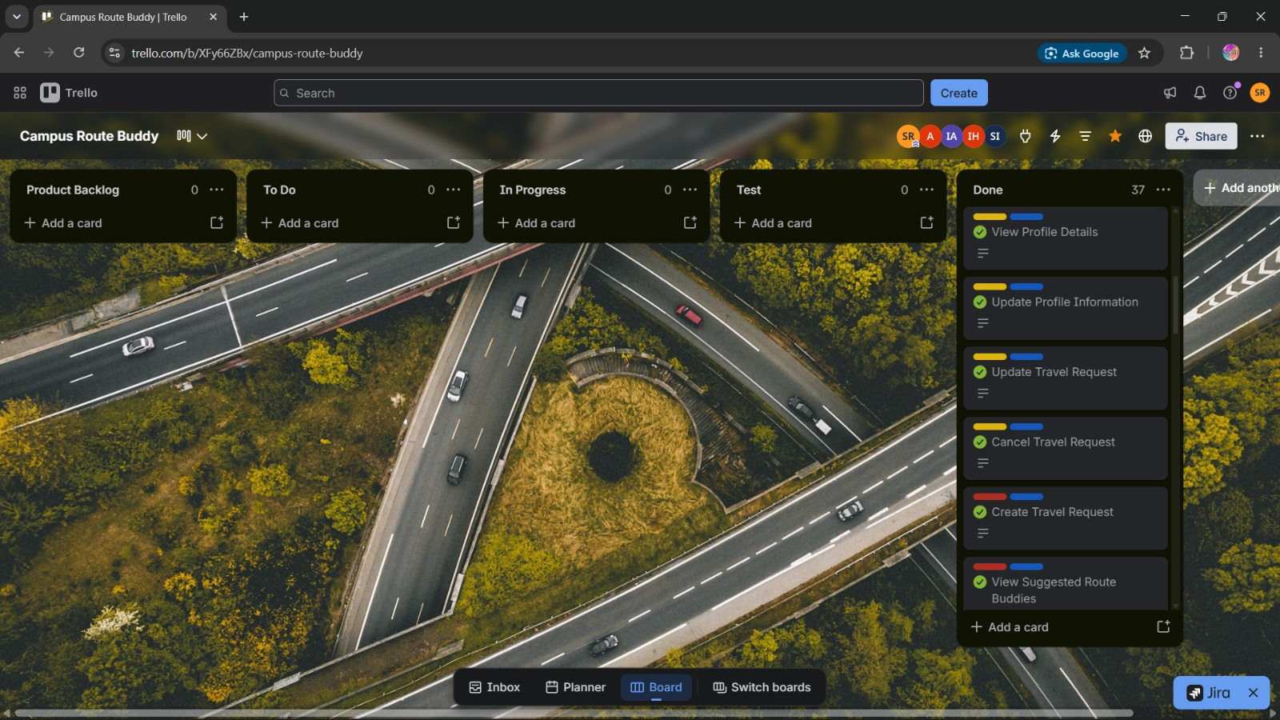
6.Git Workflow
Sabit: Akib:
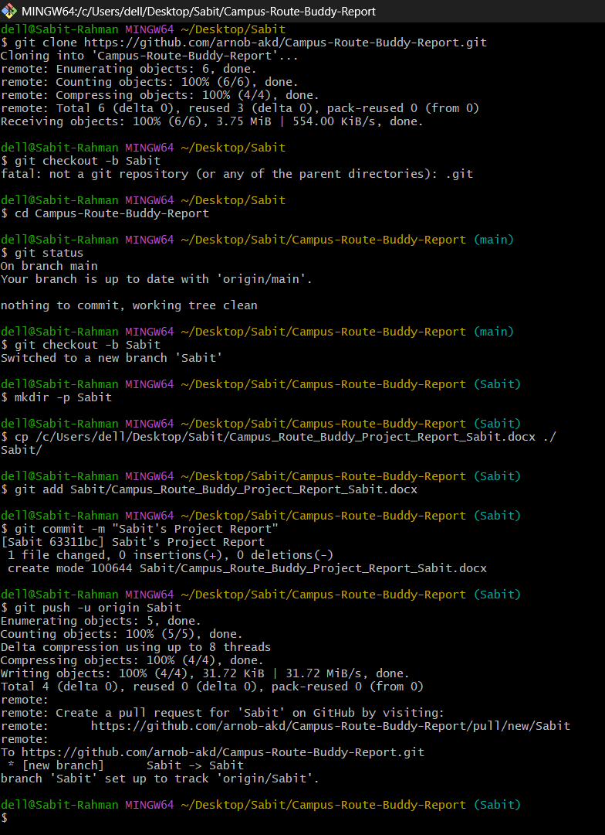 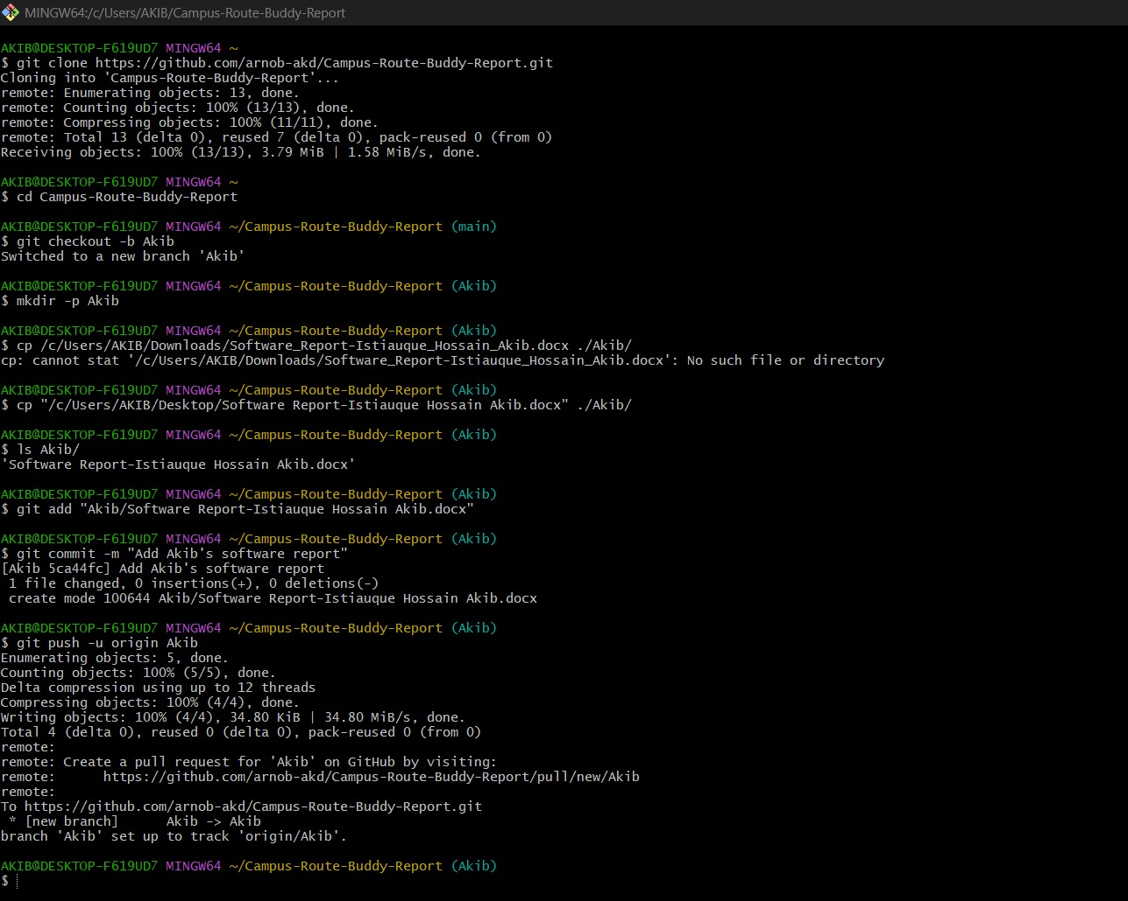

Arnob:
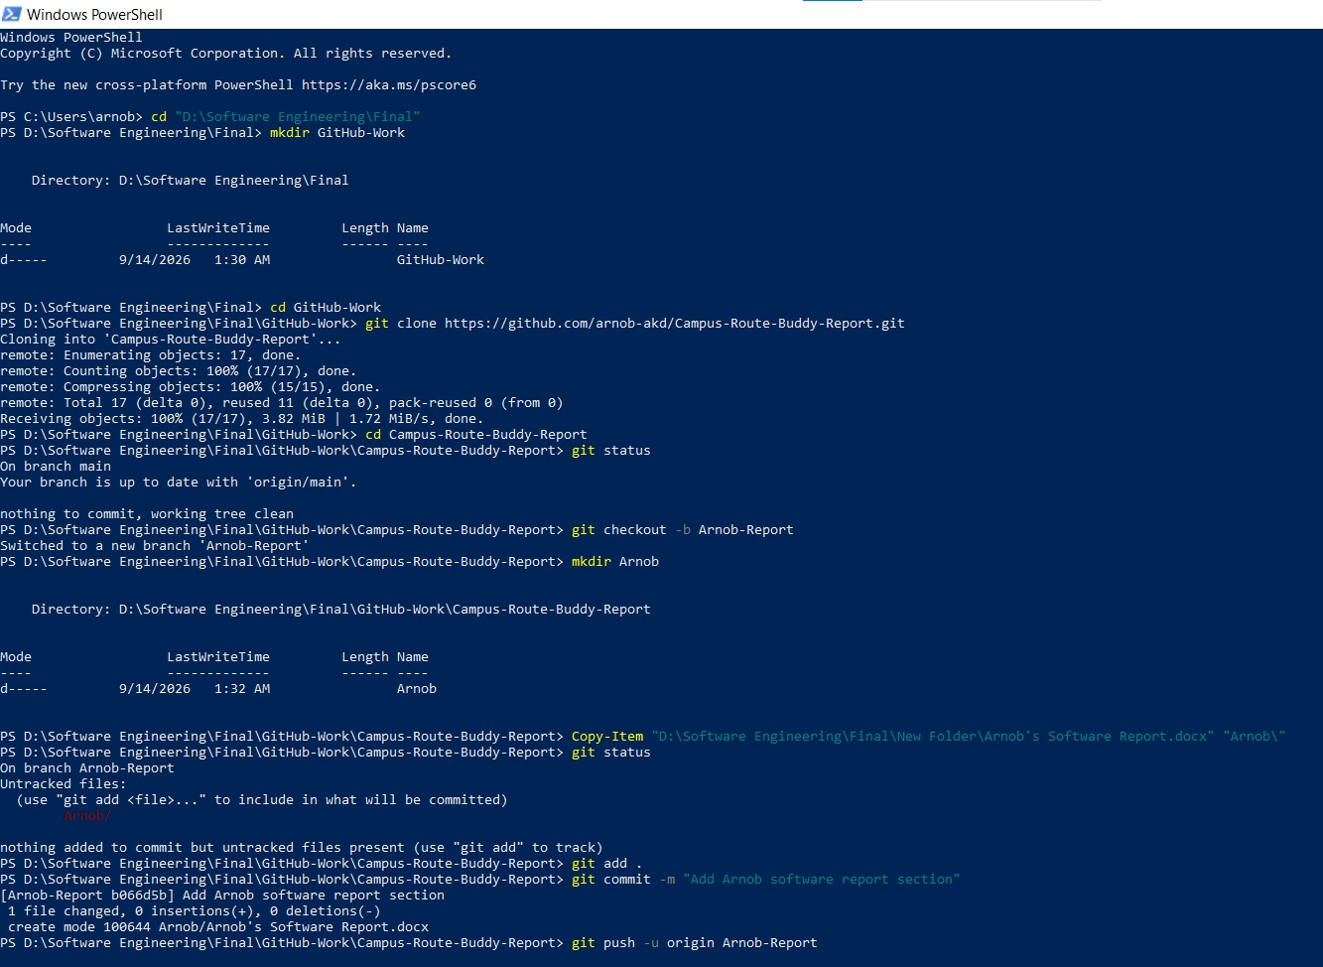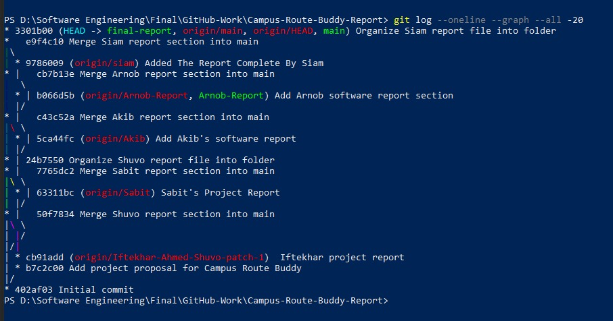
Siam: Iftekhar:

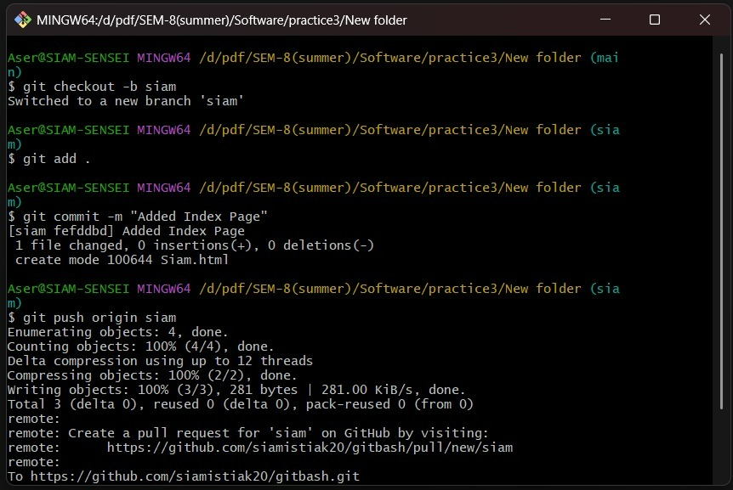

7.Conclusion
The Campus Route Buddy project was designed as a student route-matching and safe travel companion system for university students. The main purpose of this project is to help verified students find other students or route groups travelling toward the same or nearby destination. The system focuses on safety, trust, privacy, and organized trip coordination rather than transport cost calculation or payment handling.
Throughout the project, the team applied software engineering concepts such as requirement analysis, user stories, Scrum-based task planning, functional and non-functional requirements, traceability, system design, and UI prototyping. The Figma prototype represents the major user flows, including student registration, university verification, route request creation, suggested buddies, route groups, meeting point selection, trip details, safety options, trusted contact sharing, review, report, and admin management.
The project also considers important ethical and privacy concerns by avoiding public display of exact home addresses and unnecessary personal information. Admin features such as verification management, report handling, account suspension, meeting point management, permissions, and system logs support better control and safety.
Overall, Campus Route Buddy provides a practical and student-focused solution that can improve safe travel coordination within a university environment.

